Marine Biology Field Techniques Final Exam

- a)
What family is this fish from, name a related species?

b)
c)
What is the unique trait of this family?

d)
What are some traits of this family?

e)
Does the male or the female have the narrow T-shaped apron?

- a)
b)
c)

For d and e, these fish are the same species. ID the fish, list any unique characteristics for this individual species, name family and sex each tank. One is all male and the other is all female.

d)
e)

- a)
b)
What is the family name? Its traits?

c)
d) family?
e)
- a)
b)
c)
family traits?

For d, ID both invert and fish
d)
e)

- a)
b)
c)

- a)
b)
c)
d)

- a)
b)

8. For each of these organisms determine if this is a macroalgae or a flowering vascular plant.
a)
b)
c)
d)

9. Identify these as either sponge or tunicate.
a)
b)
Additionally, what phylum does this organism belong to? Why is this interesting to us as humans?

10. There are three fish in this aquarium. ID them.

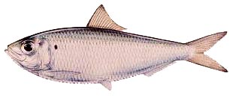
11. Common Name:

Family:

Family traits:

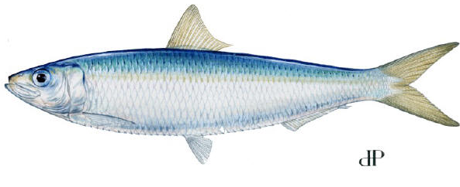
12. Common Name:

Family:

13. Identify these three mangrove trees.
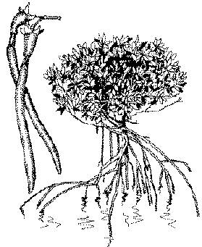
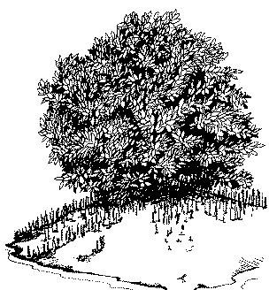

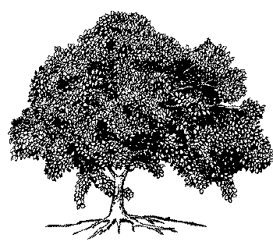

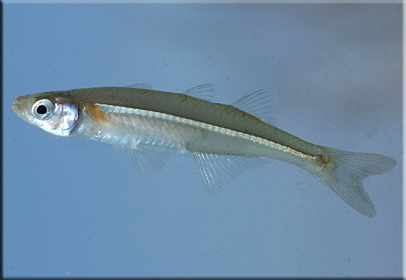
14. Is this a tidewater silverside or a bay anchovie? How do you tell?

15. Place a name next to these three seagrasses:
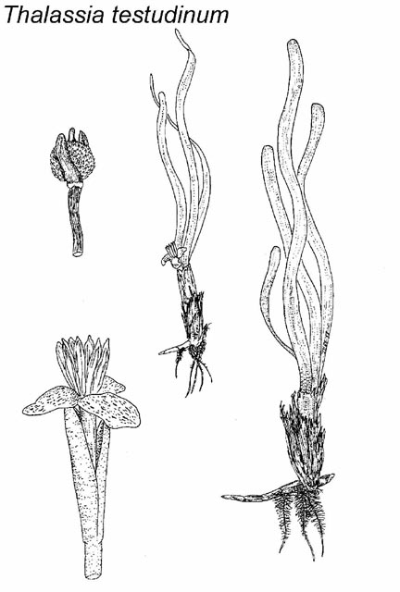

_____________________________

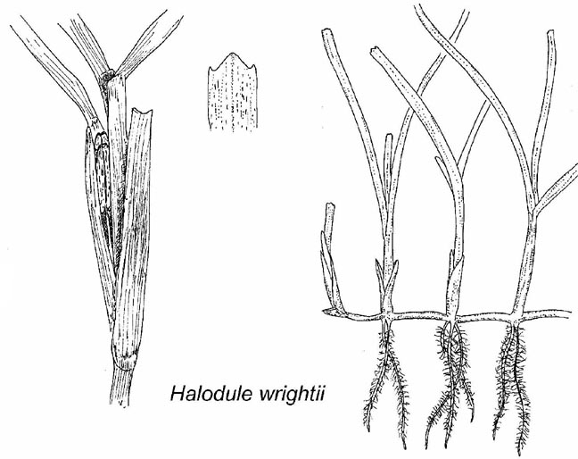

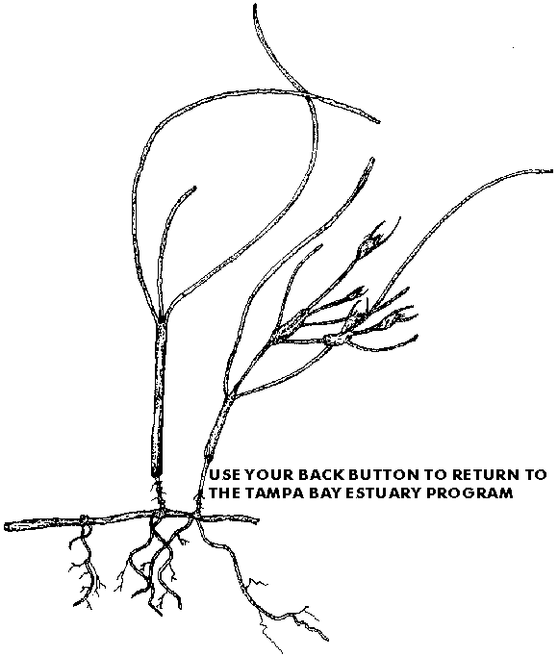
__________________

16. Name three fish you would expect to find in 6 inches of water against a sandy bank.

17.

